

Computer Science and Engineering

2023-2027

TASK-II

CA-II

Name | PRN
Gunveer Singh | 23070122098
Harsh Rajput | 23070122102
Mohammad Ahmed | 23070122140
Raghav Sharma | 23070122171

All Tasks Performed

Task1 : Pipeline for the project using Github
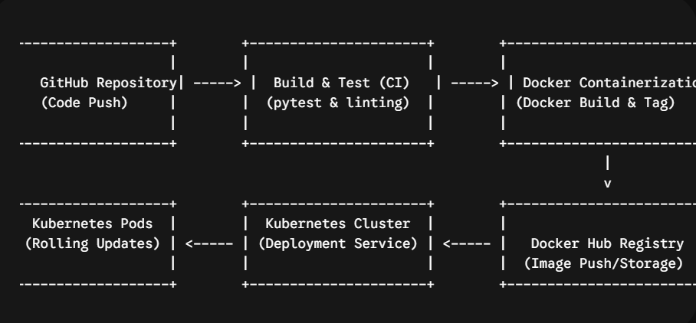

Task2 : Using ansible to display inventory and playbook
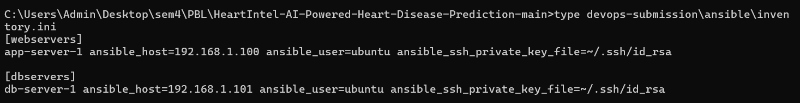
Ansible inventory.ini
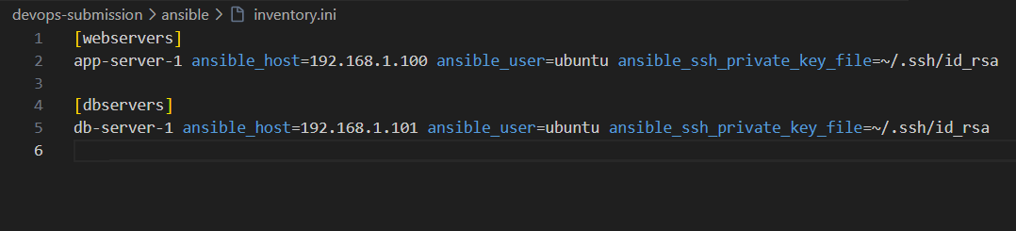
Ansible Playbook.yaml
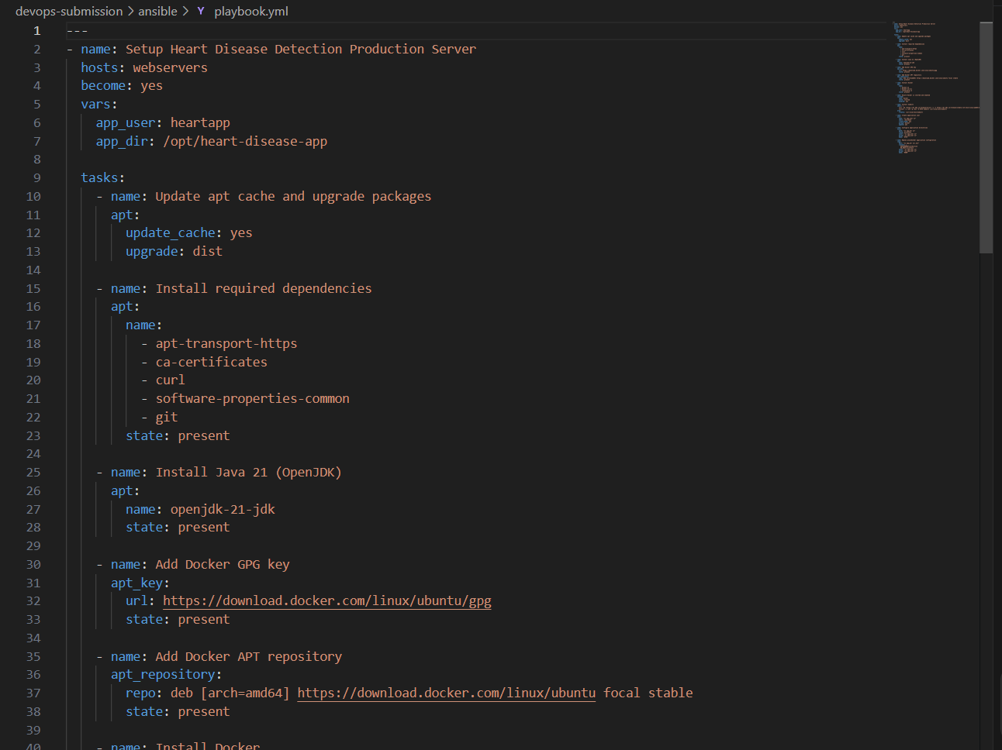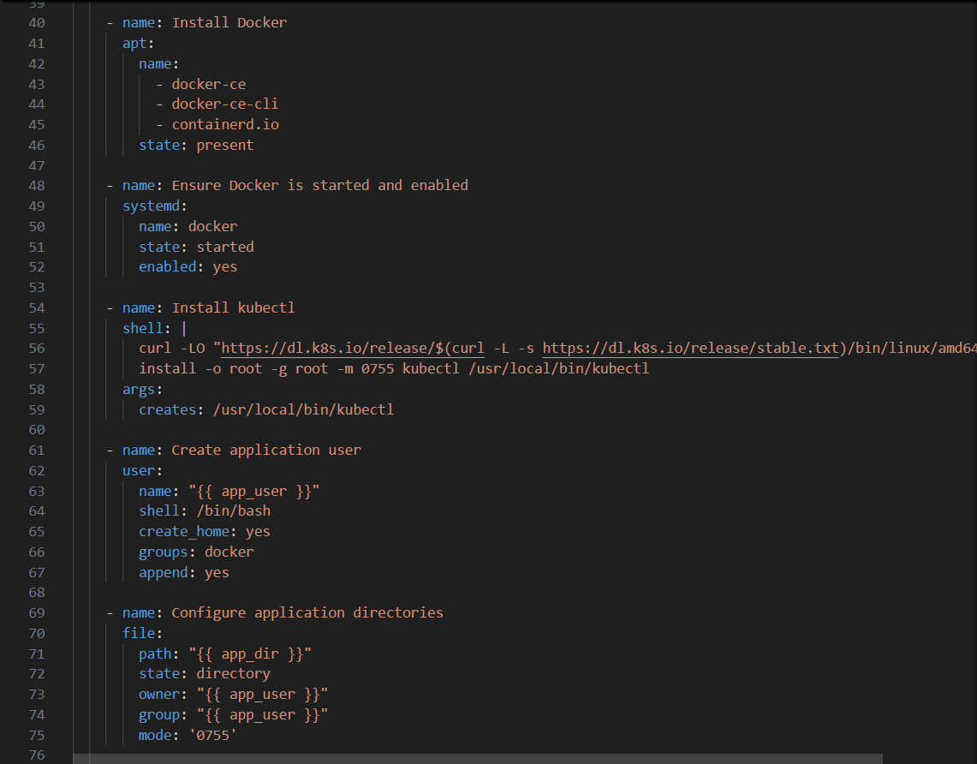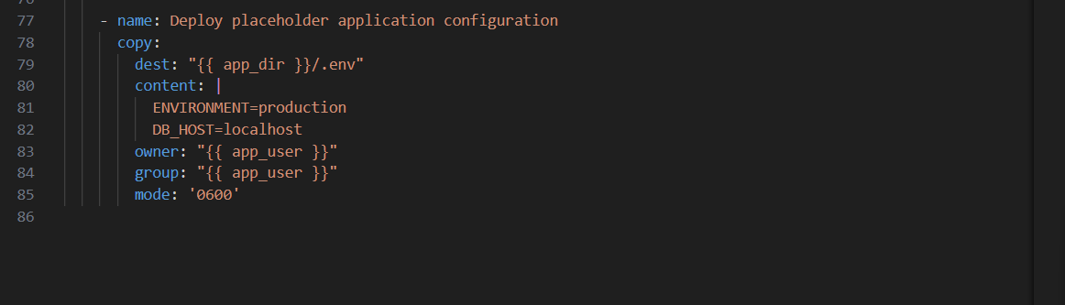

Task3: Containerization & Kubernetes manifests
Building the image using docker
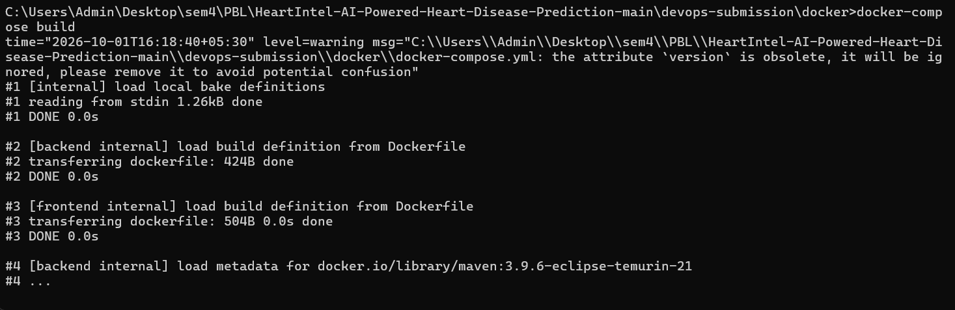
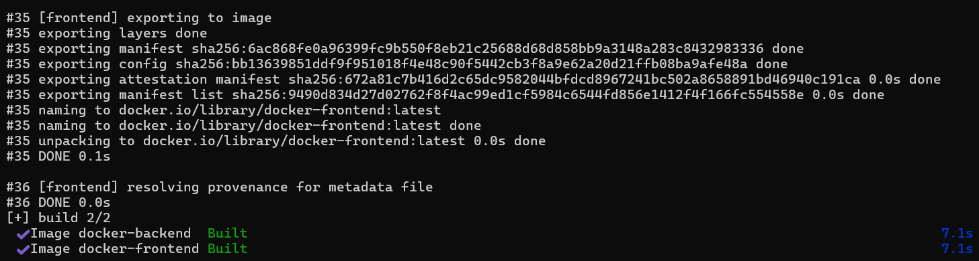
Building Kubernetes Manifests
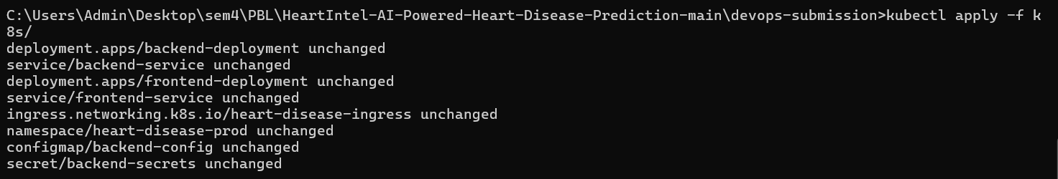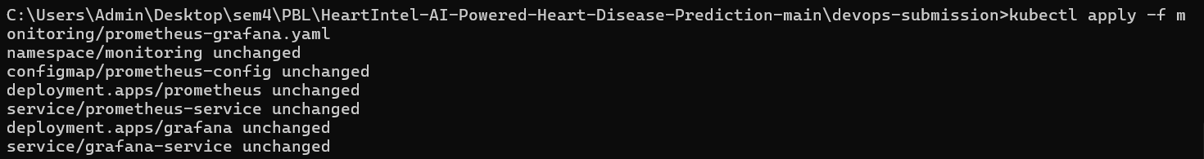
Rolling Update

Task4: Monitoring & Logging
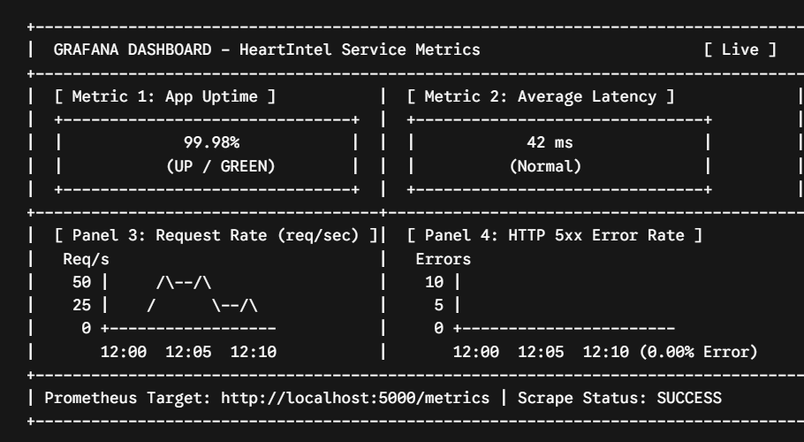
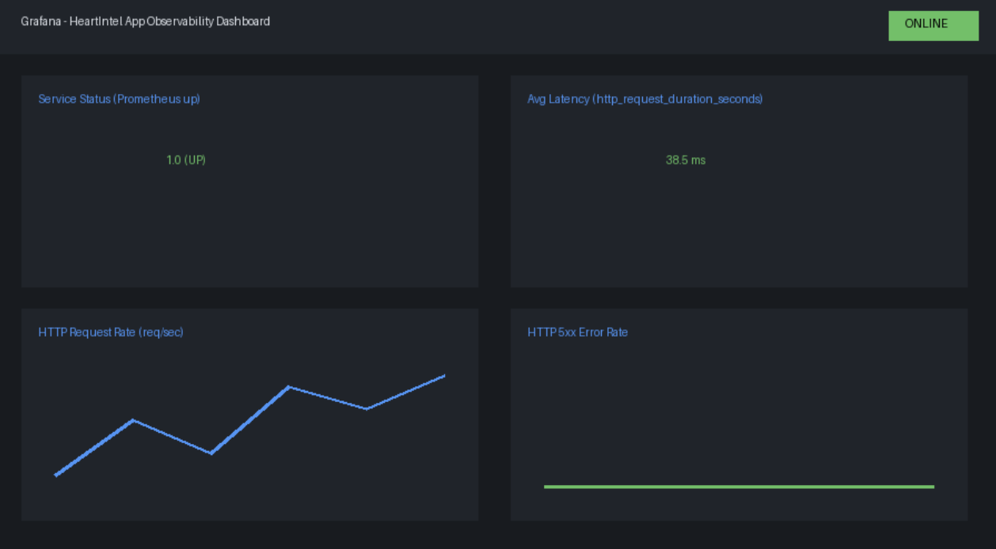
Task5 ppt : Added in the PR

